## **Data warehousing with IBM cloud DB2 warehouse**

**THAARANI S**

# **Phase-1 Document Submission**

## **Project : Data warehousing with IBM cloud DB2 warehouse**

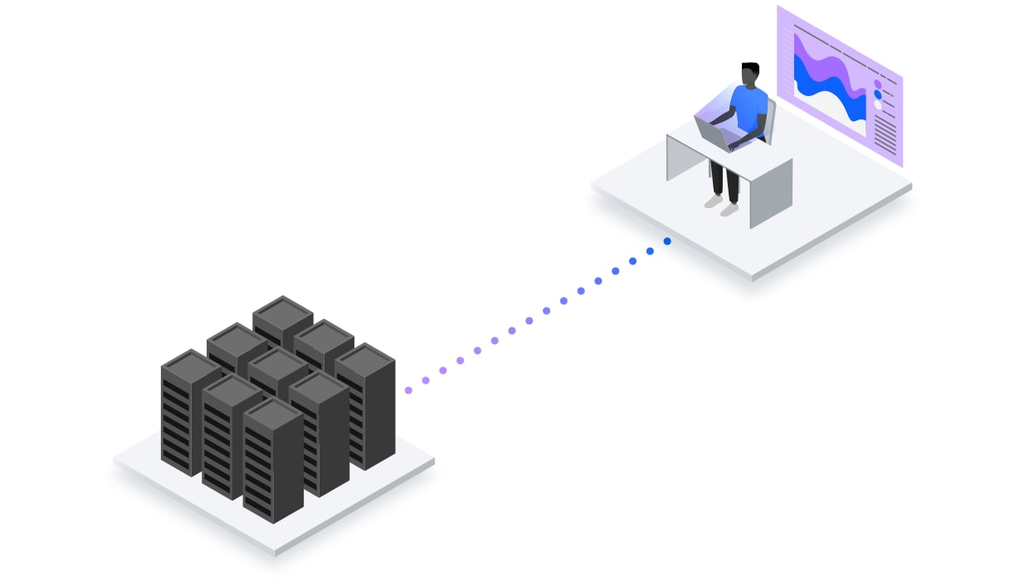

Data warehousing with IBM Cloud Db2 Warehouse offers organizations a powerful platform for managing and analyzing their data. In this essay, we will explore the key features, benefits, and considerations associated with using Db2 Warehouse on the IBM Cloud for data warehousing purposes.

IBM Cloud Db2 Warehouse is a fully managed, cloud-based data warehousing solution that enables businesses to store, manage, and analyze large volumes of data efficiently. It leverages the robust capabilities of IBM's Db2 database system and combines them with the scalability and flexibility of cloud computing. Here are some of the key features and benefits:



1. *Scalability*: One of the primary advantages of using IBM Cloud Db2 Warehouse is its scalability. Organizations can easily scale up or down based on their data needs without the hassle of procuring and managing physical hardware. This ensures that the data warehouse can grow with the business.

2. *Performance*: Db2 Warehouse is optimized for analytical workloads. It can handle complex queries and data transformations, delivering high performance even when dealing with massive datasets. This is crucial for organizations looking to derive valuable insights from their data.

3. *Integration*: Db2 Warehouse integrates seamlessly with other IBM Cloud services and data sources, making it easier to ingest and analyze data from various sources. It also supports popular analytics tools and languages like Python, R, and Jupyter notebooks.

4. *Security*: Data security is a top priority, especially in data warehousing. IBM Cloud Db2 Warehouse provides robust security features, including encryption, access controls, and auditing, to protect sensitive data and ensure compliance with regulations.

5. *Cost-Effective*: The pay-as-you-go pricing model of IBM Cloud means that organizations only pay for the resources they use. This cost-effectiveness is particularly appealing for businesses with fluctuating data processing needs.

6. *Ease of Use*: Db2 Warehouse comes with user-friendly interfaces and tools that simplify data management and analysis. This lowers the barrier to entry for organizations that might not have extensive experience with data warehousing.

7. *Backup and Recovery*: IBM Cloud Db2 Warehouse offers automated backup and recovery options, ensuring data integrity and availability in case of unexpected events.

8. *AI and Machine Learning Integration*: Organizations can harness the power of AI and machine learning by integrating Db2 Warehouse with IBM Watson services, allowing for advanced analytics and predictive modeling.

9. *Global Availability*: IBM Cloud has data centers in various regions worldwide, providing global reach and low-latency access to data, which is beneficial for multinational organizations.

While IBM Cloud Db2 Warehouse offers numerous advantages, there are some considerations to keep in mind:

1. *Cost Management*: While the pay-as-you-go model is cost-effective, organizations need to monitor their resource usage carefully to avoid unexpected costs.

2. *Data Integration Complexity*: Integrating data from multiple sources can be complex, and organizations may need to invest in data integration tools and expertise.

3. *Vendor Lock-In*: Choosing a cloud-based solution like IBM Cloud Db2 Warehouse may lead to vendor lock-in, making it challenging to switch to another platform in the future.

In conclusion, IBM Cloud Db2 Warehouse is a robust and versatile solution for data warehousing in the cloud. Its scalability, performance, and integration capabilities make it a valuable asset for organizations seeking to harness the power of their data for strategic decision-making and analytics. However, careful planning and cost management are essential to maximize the benefits while minimizing potential drawbacks.